** DOMINICAN COLLEGE OF TARLAC**

Mac Arthur Highway, Poblacion (Sto.Cristo), Capas. 2315 Tarlac, Philippines

Tel.No. (045) 491-7579/Telefax (045) 925-0519

E-mail: domct _2315@yahoo.co

**COLLEGE DEPARTMENT**

A.Y. 2020-2021, Second Semester

**OBE FACULTY - DESIGNED MODULE**

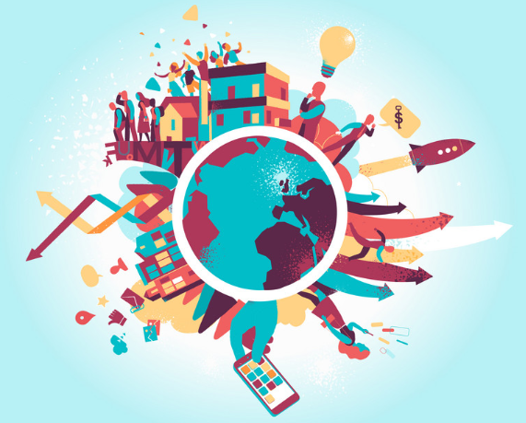

**THE CONTEMPORARY WORLD**

MODULE 3: The Global Economy

**I. Subject: GE3 - The Contemporary World**

**II. Learning Outcomes:**

1. Define economic globalization.

2. Identify the actors that facilitate economic globalization.

III. The Global Economy

**IV. Days of Learning Sessions:**

**Online/Modular**

BSIT 1A - Wednesday/Friday

BSIT 1B - Wednesday/Friday

BSIT1C - Tuesday/Thursday

V, Expected Outcome:

1. Describe the emergence of global economic, political, social and cultural systems

**VI.Delivery:**

1. **Thought Processing**
   1. **Pre-assessment Activity (Collaboration)**



Activity 1

Follow the Product

The products that we consume and use—foods, clothing, and gadgets—are part of our way of life. Globalization allows for a worldwide exchange of these commodities and exposure to different cultures as well.

1. Divide the class into six groups. Each group will be assigned to any one of the following products being sold in the Philippines. The group shall choose a specific foreign brand of the product assigned to them.

a. coffee d. hamburger

b. sports car e. wristwatch

c. laptop f. shoes

2. List down the main ingredients or raw materials in manufacturing the chosen product. Identify the corresponding country from which each ingredient or raw material came from.

3. Identify the countries involved in the manufacturing of the chosen product. Indicate the corresponding service the country does for the product (e.g., Costa Rica - planting of coffee beans).

4. Aside from the Philippines, list other countries in which the product is being sold.

5. Cite the kinds of technology that made the creation of the product " possible. Consider communications and transportation.

6. Write one to three statements about the creation of the product. Share your statement with your groupmates and indicate whether you agree or disagree with their statements.

PRESENTATION PHASE

**Introduction**

The United Nations (UN) tried to address the different problems in the world. Their efforts were guided by the eight Millennium Development Goals, which they created in the 1990s. Among these eight goals, the eradication of extreme poverty and hunger, ranked as the first. The other seven goals include: achieving universal primary education, promoting gender equality and women empowerment, reducing child mortality, improving maternal health, combating diseases like HIV/AIDS and malaria, ensuring environmental sustainability, and having a global partnership for development (United Nations, 2015). The UN tried to achieve them by the year 2015.

Why is extreme poverty falling? The answer to this is really complicated. A set of factors like better access to education, humanitarian, aid, and the policies of international organizations like the UN have made a difference. However, the greatest contributor is economic globalization. The world's economies have become more interconnected and free trade has driven the growth of many developing economies.

**Economic Globalization and Global Trade**

According to the United Nations (as cited in Shangquan, 2000), “Economic globalization refers to the increasing interdependence of world economies as a result of the growing scale of cross-border trade of commodities and services, flow of international capital, and wide and rapid spread of technologies. It reflects the continuing expansion and mutual integration of market frontiers, and is an irreversible trend for the economic development in the whole world at the turn of the millennium." (p. 1)

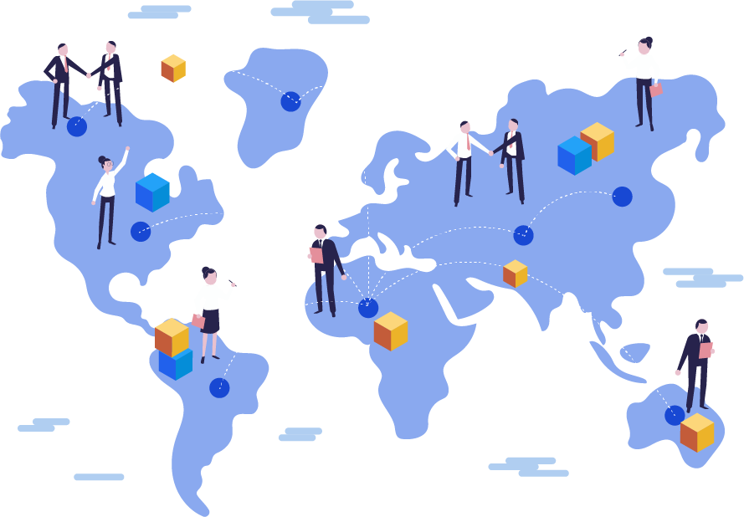

There are two different types of economies associated with economic globalization-**protectionism** and **trade liberalization**. **Protectionism** means “a policy of systematic government intervention in foreign trade with the objective of encouraging domestic production. This encouragement involves giving preferential treatment to domestic producers and discriminating against foreign competitors” (McAleese, 2007 as cited in Ritzer, 2015, p. 1169). **Trade protectionism** usually comes in the form of quotas and tariffs. Tariffs are required fees on imports or exports. For instance, a pen that costs $1.00 in Country A and in Country B, it would be given five-dollar tariff. The pen would become $6 in Country B. This policy was practiced during the mercantilist era, from sixteenth to seventeenth centuries until the early years of the Industrial Revolution (Chorev, 2007). The Great Depression of 1929 marked the peak of protectionism. Until today, protectionism exists in the world economy despite the growth of trade liberalization. Countries such as China, Japan, and the United States are being accused of practicing protectionism (Ritzer, 2015).

**Economic Globalization and Sustainable Development**

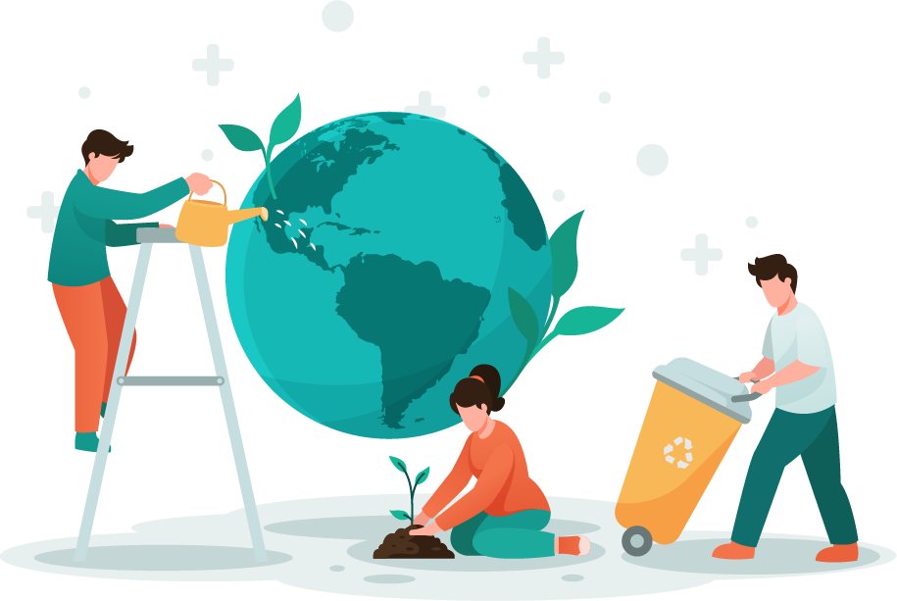There are some significant downsides to globalize trade and perhaps the strongest argument against economic globalization is its lack of sustainability or the degree to which the earth’s resources can be used for our needs, even in the future. Specifically, the development of our world today by using the earth’s resources and the preservation of such sources for the future is called *sustainable development.*

In other words, development has to be ensured in and for the future generations. One significant global response or approach to economic globalization is that of sustainable development, which seeks to chart a middle path between economic growth and a sustainable environment (Borghesi and Vercelli, 2008). The relationship between globalization and sustainability is multi¬ dimensional—it involves economic, political, and technological aspects.

The continuous production of the world’s natural resources, such as water and fossil fuel allows humanity to discover and innovate many things. We were able to utilize energy, discover new technologies, and make advancements in transportation and communication. However, these positive effects of development put our environment at a disadvantage. Climate change accelerated and global inequality was not eradicated. This means that development, although beneficial at one hand, entails cost on the other.

**Environmental Degradation**

Development, especially economic development, was hastened by the Industrial Revolution. This is the period in human history that made possible the cycle of efficiency. Efficiency means finding the quickest possible way of producing large amounts of a particular product. This process made buying of goods easier for the people. Then, there is an increased demand. Ultimately, there was an increased efficiency. This cycle harms the planet in a number of ways. For instance, the earth’s atmosphere is damaged by more carbon emissions from factories around the world. Another example is the destruction of coral reefs and marine biodiversity as more and more wastes are thrown into the ocean. Many experts do not think that the planet can sustain a growing global economy. Deforestation, pollution, and climate change will not adjust for us, especially if increases in living standards lead people to demand more consumer goods like cars, meat, and smartphones.

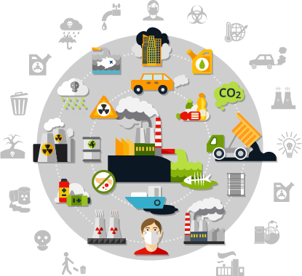

**Food Security**

The demand for food will be 60% greater than it is today and the challenge of food security requires the world to feed 9 billion people by 2050 (Breene, 2016). Global food security means delivering sufficient food to the entire world population. It is, therefore, a priority of all countries, whether developed or less developed. The security of food also means the sustainability of society such as population growth, climate change, water scarcity, and agriculture.

But perhaps the closest aspect of human life associated with food security is the environment. The challenges to food security can be traced to the protection of the environment. A major environmental problem is the destruction of natural habitats, particularly through deforestation (Diamond, 2006). Industrial fishing has contributed to a significant destruction of marine life and ecosystems (Coldburg, 2008). Biodiversity and usable farmland 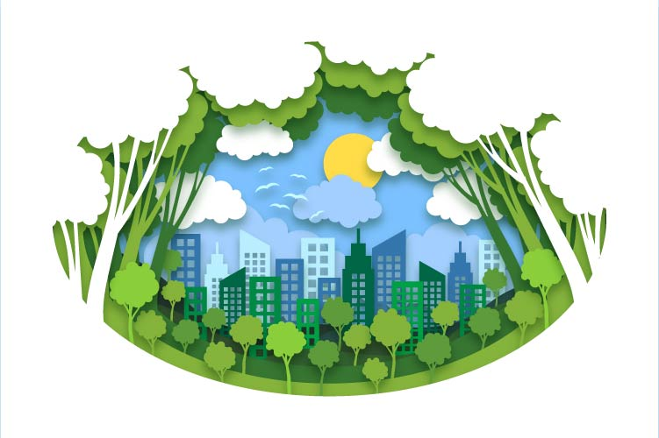have also declined at a rapid pace.

Another significant environmental challenge is that of the decline in **the availability of fresh** water (Conca, 2006). The decline in the water supply because of degradation of soil or desertification (Glantz, 1977), has transformed what was once considered a public good into a privatized commodity. The poorest areas of the globe experience a disproportionate share of water-related problems. The problem is further intensified by the consumption of “virtual water,” wherein people inadvertently use up water from elsewhere in the world through the consumption of water-intensive products (Ritzer, 2015). The destruction of the water ecosystem may lead to the creation of “climate refugees, people who are forced to migrate due to lack of access to water or due to flooding” (Ritzer, 2015, p. 211).

**Pollution through toxic chemicals** has had a long-term impact on the environment. The use of persistent organic pollutants (POPs) has led to significant industrial pollution (Dinham, 2007). Greenhouse gases, gases that trap sunlight and heat in the earth’s atmosphere, contribute greatly to global warming. In turn, this process causes the melting of land-based and glacial ice with potentially catastrophic effects (Revkin, 2008), the possibility of substantial flooding, a reduction in the alkalinity of the oceans, and destruction of existing ecosystems. Ultimately, global warming poses a threat to the global supply of food as well as to human health (Brown, 2007). Furthermore, population growth and its attendant increase in consumption intensify ecological problems. The global flow of dangerous debris is another major concern, with electronic waste often dumped in developing countries.

There are different models and agenda pushed by different organizations to address the issue of global food security. One of this is through sustainability. The United Nations has set ending hunger, achieving food security and improved nutrition, and promoting sustainable agriculture as the second of its 17 Sustainable Development Goals (SDGs) for the year 2030. The World Economic Forum (2010) also addressed this issue through the New Vision for Agriculture (NVA) in 2009 wherein public-private partnerships were established. It has mobilized over $10 billion that reached smallholder farmers. The Forum's initiatives were launched to establish cooperation and encourage exchange of knowledge among farmers, government, civil society, and the private sector in both regional and national levels (Breene, 2016).

**Economic Globalization, Poverty, and Inequality**

The Swedish statistician Hans Rosling once said, “The 1 to 2 billion poorest in the world who don’t have food for the day suffer from the worst disease, globalization deficiency. The way globalization is occurring could be much better, but the worst thing is not being part of it.”

Economic and trade globalization is the result of companies trying to outmaneuver their competitors. While you search for the cheapest place to buy shoes, companies search for the cheapest place to make those shoes. They find the cheapest sources of leather, dye, rubber, and of course, labor. The result is that labor-intensive products like shoes are often produced in countries with the lowest wages and the weakest regulations. This process creates winners and losers. The winners include corporations and their stockholders who earn more profit. They also include consumers who get products at a cheaper price. The losers are high wageworkers who used to make those shoes. Their jobs moved overseas. But what about the low wage foreign workers? Are they winning or losing? A lot of workers are thrown into hazardous working conditions but it is also true that many workers in developing countries are at least making more money. These jobs pay above average wages. People want these jobs and although the pay would be unacceptable in developed countries, they are often the best alternative.

The *multiplier effect* means an increase in one economic activity can lead to an increase in other economic activities. For instance, investing in local businesses will lead to more jobs and more income. According to the economist Paul Krugman (as cited in The New York Times, July 8, 2013), “The Bangladeshi apparel industry is going to consist of what we would consider sweatshops or it won’t exist at all. And Bangladesh, in particular, really needs its apparel industry. It’s pretty much the only thing keeping its economy afloat.”

Not everyone agrees to this. Opponents of economic globalization called the outsourcing of jobs as exploitation and oppression, a form of economic colonialism that puts profits before people, A few call for protectionist policies like higher tariffs and limitations on outsourcing. Others focus on the foreign workers themselves by demanding they receive higher wages and more protection. The root of many arguments against economic globalization is that companies do not have to follow the same rules they do in developed countries. Some developing countries have no minimum wage laws. They do not have regulations that provide safe working conditions or protect the environment. Although nearly 1 every country bans child labor, those laws are not always enforced.

**Global Income Inequality**

Globalization and inequality are closely related. We can see how different nations are divided between the North and the South, developed and less developed, and the core and the periphery. These differences mainly reflect one key aspect of inequality in the contemporary world—global economic inequality. There are two main types of economic inequality: wealth inequality and income inequality. Wealth refers to the net worth of a country. It takes into account all the assets of a nation—may they be natural, physical, and human—less the liabilities. In other words, wealth is the abundance of resources in a specific country. This means that wealth inequality speaks about distribution of assets. However, there is no widely recognized, monetary measure that sums up. these assets (Economist, 2012).

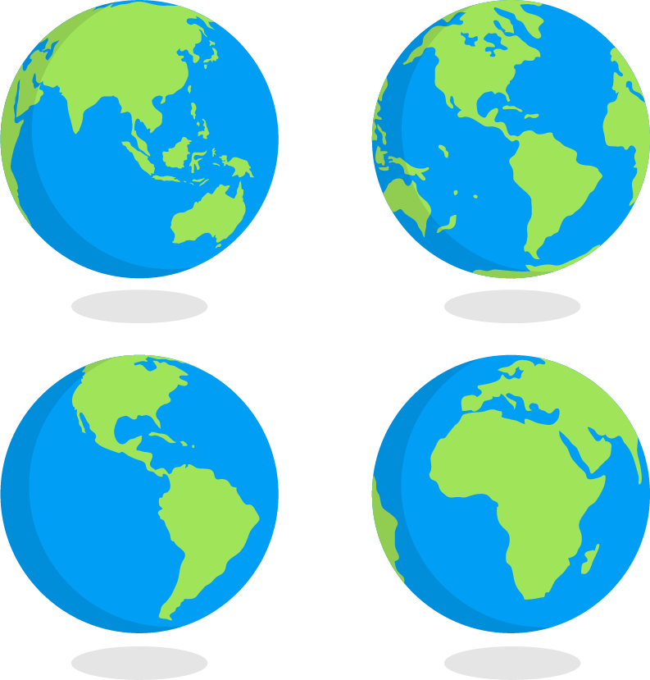

In order to measure global economic inequality, economists usually look at income using the Gross Domestic Product (GDP). Income is the new earnings that are constantly being added to the pile of a country’s wealth. When we talk about income inequality, we mean that new earnings are being distributed; it values the flow of goods and services, not a stock of assets (Economist, 2012).

Although it is the Industrial Revolution that allowed a significant inequality in the past, economic globalization and international trade are the forces responsible in today’s global income inequality. Many economists believe that the world’s poorest people gained something from globalization. The rich, on the other hand, earned a lot more. Harvard economist Richard Freeman (2011) noted, “The triumph of globalization and market capitalism has improved living standards for billions while concentrating billions among the few” (as presented in OECD Policy Forum, Paris, May 2). In other words, the poor are doing a little better and the rich are becoming richer due to global capitalism.

Access to technology also contributed to worldwide income inequality. It complemented skilled workers but replaced many unskilled workers. In modernized economies, jobs are more technology-based, generally requiring new skills. This is what economists referred to as skill-based technological change. As a result, workers who are more educated and more skilled would thrive in those jobs by receiving higher wages. On the other hand, the unskilled workers will fall behind. They will be left or overtaken by machines or more skilled workers. In addition, manufacturing jobs that require low skills are moved overseas. The result is a widening gap between the rich and the poor as well as between high skilled and low-skilled workers.

**The Third World and the Global South**

You probably heard of “First World Problems.” When someone cracks the screen on their phone or gets the wrong order at the coffee shop, and then goes on to their social media accounts, you might see their complaints with a hashtag “First World Problems.” What are the implications of talking about countries as First or Third? Where did these terms come from? These terms are outdated and inaccurate ways of talking about global stratification. How then are we going to talk about global stratification?

Let us begin by deconstructing the idea of the First, Second, and Third World hierarchy by looking at their origins and their implications. The terms date back to the Cold War, when Western policymakers began talking about the world as three distinct political and economic blocs (Tomlinson, 2003). Western capitalist countries were labeled as the “First World.” The Soviet Union and its allies were termed the “Second World.” Everyone else was grouped into “Third World.” After the Cold War ended, the category of Second World countries became null and void, but somehow the terms “First World” and “Third World” stuck around in the public consciousness. Third World countries, which started as just a vague catchall term for non-alliance countries, came to be associated with impoverished states, while the First World was associated with rich, industrialized countries.

A new and simpler classification, North-South, was created as Second World countries joined either the First World or the Third World. First World countries, such as the United States, Canada, Western Europe, and developed parts of Asia are regarded as the “Global North,” while the “Global South” includes the Caribbean, Latin America, South America, Africa, and parts of Asia. These countries were used to be called the Third World during the Cold War (Reuveny & Thompson, 2007). By noting that countries are south of 30 degrees north latitude, they are able to say that these areas share common problems and issues having to do with economy and politics. The terms “Global North” and Global South are a way for countries in the South to make a stand about the common issues, problems, and even causes in order to have equality all throughout the world.

These distinctions point largely to racial inequality, specifically between the Black and the White. According to Ritzer (2015), “At the global level, whites are disproportionately in the dominant North, while blacks are primarily in the south, although this is changing with South-to-North migration” (p. 266). In other words, the differences between the Global North and the Global South are shaped by migration and globalization. Nevertheless, the economic differences between the wealthy Global North and poor Global South “have always possessed a racial character” (Winant, 2001, p. 131).

**The Global City**

The rural-urban differentiation has a significant relationship to globalization. Globalization has deeply altered North-South relations in agriculture. For instance, the relations of agricultural production have been altered due to the rise of global agribusiness and factory farms (McMichael, 2007). In this scenario, the South produces non-traditional products for export and become increasingly dependent on industrialized food exports from the North. Consequently, this leads to a replacement of the staple diet as well as the displacement of local farmers. Schlosser (2005) pointed out that as commercial agriculture replaces local provisioning, the relations of social production are also altered. Rural economies are exposed to low prices and mass migration.



Although cities are major beneficiaries of globalization, Bauman (2003) claimed that they are also the most severely affected by global problems. Therefore, the city faces peculiar political problems, wherein it is often fruitlessly seeking to deal locally with global problems and “local politics has become hopelessly overloaded” (p. 102).



Activity 2

Analysis

Answer the following questions.

1. Do you think that the Philippines is harmed as other countries transfer their activities to us through outsourcing?

**No. In fact, the Philippines benefits from it. When a certain company in other countries involves itself in an outsourcing _______________________________________________________________________**

_______________________________________________________________________

_______________________________________________________________________

_______________________________________________________________________

_______________________________________________________________________

2. In what ways do international organizations help our country’s economy? _______________________________________________________________________

_______________________________________________________________________

_______________________________________________________________________

_______________________________________________________________________

_______________________________________________________________________

_______________________________________________________________________

_______________________________________________________________________

_______________________________________________________________________

_______________________________________________________________________

3. Does the position of rich countries as giants in the economic chain threaten the status of less developed countries in the global market? _______________________________________________________________________

_______________________________________________________________________

_______________________________________________________________________

_______________________________________________________________________

_______________________________________________________________________

_______________________________________________________________________

_______________________________________________________________________

_______________________________________________________________________



Activity 3

Abstraction

Answer the following questions.

1. What is the impact of global flows on the global South?

**Globalization has had a deep effect on cities all over the world, not the least in South Africa where the isolation of the apartheid years has given way to a much more open society and economy. Businesses, cities and regions that flourished in the years of isolation are in decline.**

2. Examine the gap between rural and urban areas across the globe. How is that gap affected by globalization?

**Findings indicate that the urban-rural income gap has been widening since China began to integrate into the world economy, but globalization is not the principal reason for the increase. ... In fact, findings indicate that foreign direct investment has actually helped to reduce inequality**

3. What do you think is the impact of urbanization and the rise of global city on the agricultural sector?

**Poor air and water quality, insufficient water availability, waste-disposal problems, and high energy consumption are exacerbated by the increasing population density and demands of urban environments. Strong city planning will be essential in managing these and other difficulties as the world's urban areas swell.**



Activity 4

The Global Free Trade on Trial

This is a debate activity which intends to show the stance of the students regarding economic globalization. Argue based on this statement: "Global free trade has done more harm than good.”

ASSESSMENT PHASE

*See Schoology.*

**REFERENCE:**

Aldama, P. (2018). *The contemporary world.* Manila, Philippines: Rex Book Store.

Photos: Freepik